Web Infrastructure:
Web Applications Infrastructure/Web Infrastructure also called internet infrastructure is the physical hardware, transmission media, and software used to interconnect computers and users on the Internet.

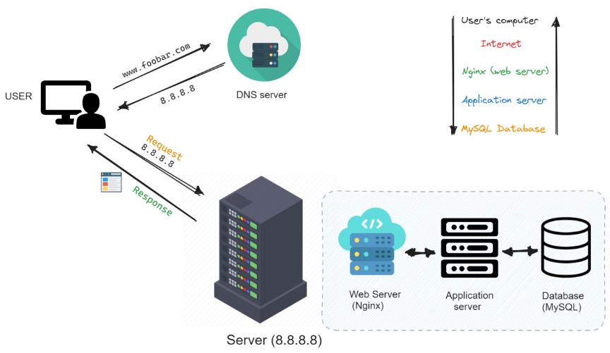

Web Server:
A web server is a combination of hardware and software that stores and delivers website content to users over the internet. When a user's browser requests a web page, the web server receives the request, processes it, and sends back the requested files, such as HTML pages, images, and videos, via the HTTP/HTTPS protocol. The term can refer to the physical machine that stores the data or the software, like Apache or Nginx, that handles the requests.

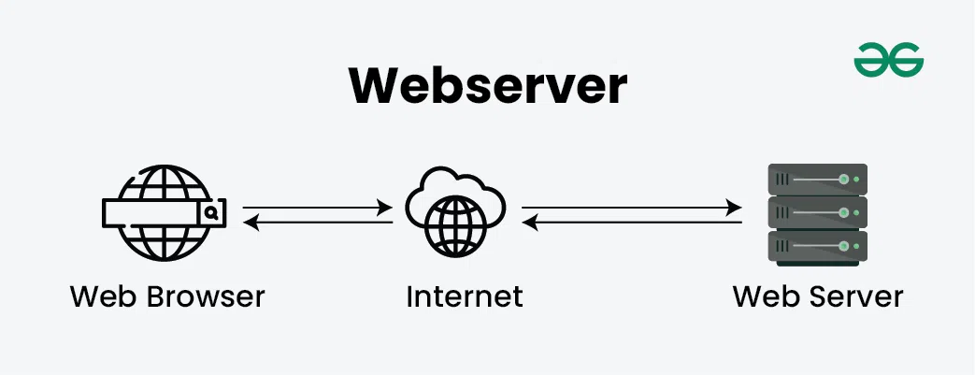

Application Server
An application server is a software framework that provides the business logic and infrastructure for running applications, acting as a middle layer between a client and backend resources like databases. It processes requests, generates dynamic content, and handles the core functionality of an application, such as web, mobile, and enterprise applications. Popular examples include JBoss, WebSphere, and Tomcat.

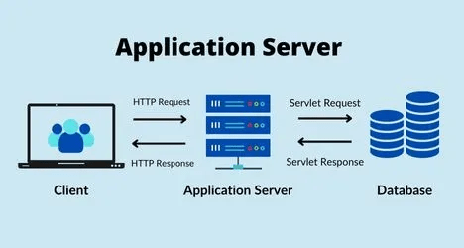

Database:
A database is an organized collection of data, stored and accessed electronically, designed to efficiently manage large amounts of information, allowing users to store, retrieve, update, and analyze data using specific software called a Database Management System (DBMS). Databases use structures like tables with rows (records) and columns (fields) to organize data, with different types (Relational, NoSQL, Vector) offering flexibility for various needs, from structured financial systems to AI-driven recommendations

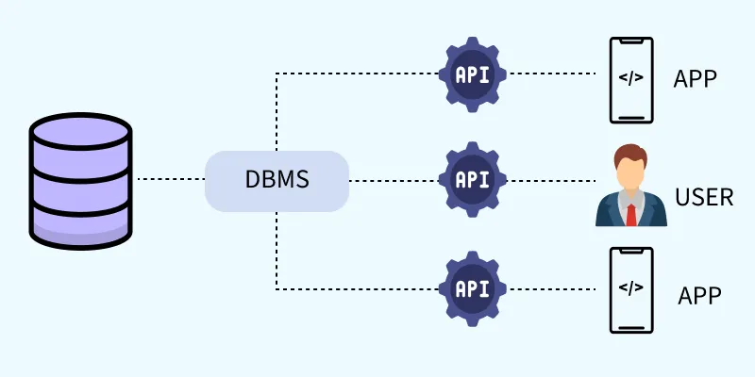

Firewall:
A firewall is a network security system acting as a digital gatekeeper, monitoring and controlling incoming/outgoing traffic between trusted and untrusted networks (like your home and the internet) based on predefined rules to block unauthorized access and threats, existing as hardware (your router), software (on your PC), or both, crucial for preventing malware, viruses, and data breaches

